

**UIC-A**

**Universal ICSP Socket**

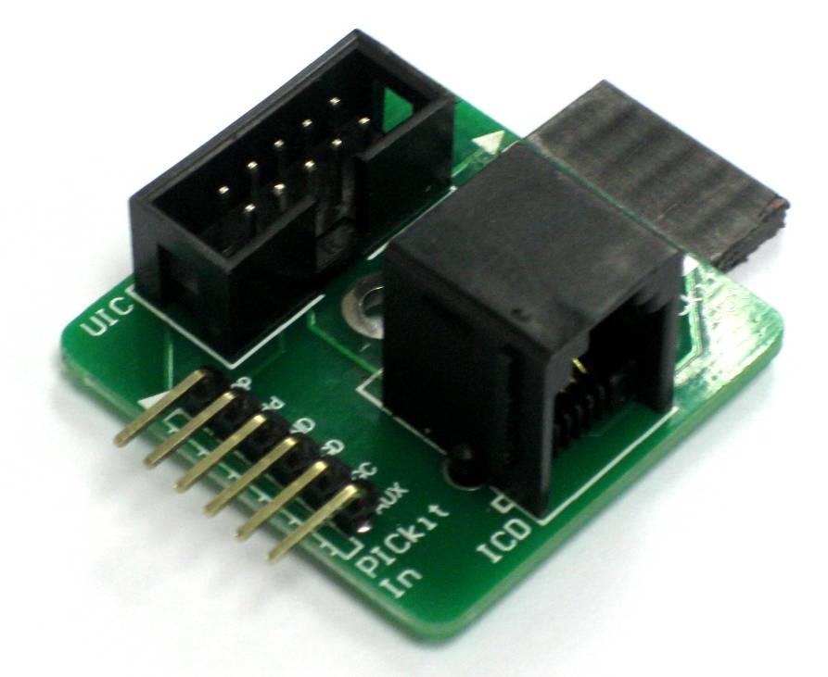

**User's Manual**

**V1.0**

**June 2010**



**INDEX**

1. Introduction/Overview  3
2. Packing List 4

1. Dimension 5
2. Board Layout  6
3. Hardware 8
4. Warranty 10

**1. INTRODUCTION/OVERVIEW**

[UIC-A](http://cytron.com.my/p-uic-a) (Universal ICSP Adapter) is designed as a programmer’s output socket adapter which are compatible to Cytron [UIC00B programmer](http://cytron.com.my/p-uic00b), [Microchip PICkit programmer](http://cytron.com.my/p-pickit-3) and [Microchip In Circuit Debugger](http://cytron.com.my/p-icd3). Each of them has their own standard connection. To ease user, Cytron has created this UIC-A so that user can use any programmer regardless of the development board. For example, a development board which uses PICkit2’s socket standard, which is 6 way header pins can be programmed with UIC00B by using the UIC-A!

**2. PACKING LIST**

Please check the parts and components according to the packing list. If there are any parts missing, please contact us at sales@cytron.com.my immediately.

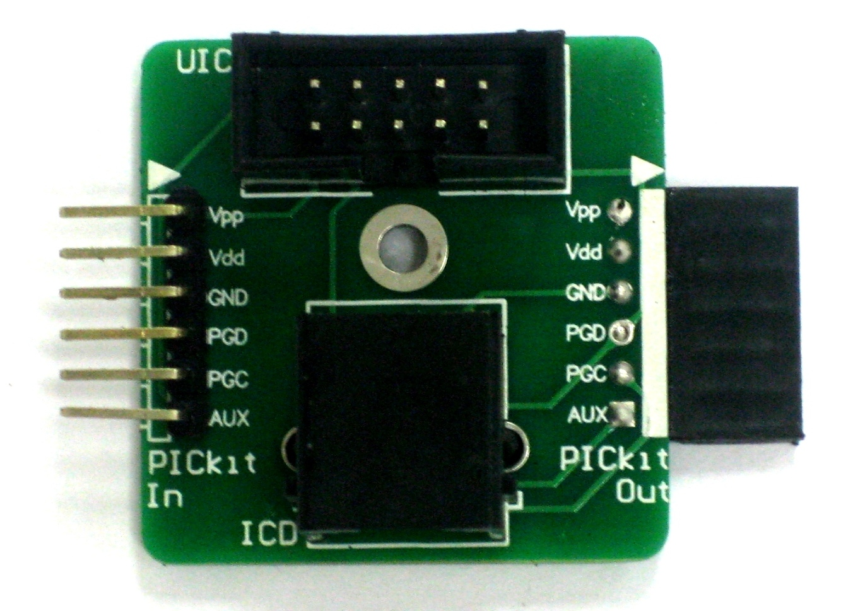

1. 1 x [UIC-A](http://cytron.com.my/p-uic-a)

**3****. DIMENSION**

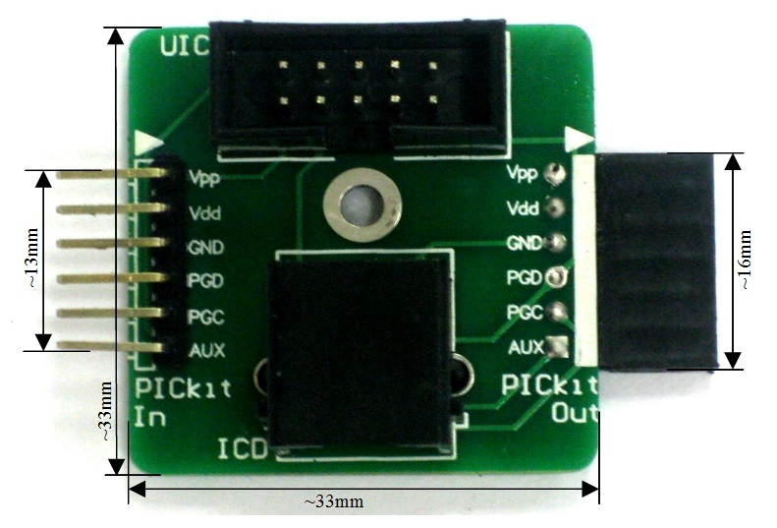

**4****. BOARD LAYOUT**

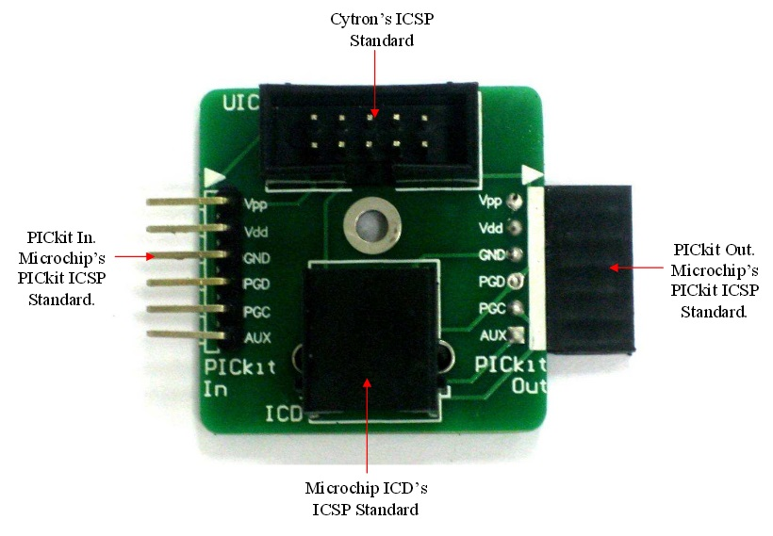

**Cytron’s ICSP Pinout**

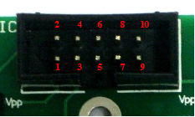

|  |  |  |  |
| --- | --- | --- | --- |
| **PIN** | **DESCRIPTION** | **PIN** | **DESCRIPTION** |
| 1 | NC | 6 | GND |
| 2 | NC | 7 | PGD |
| 3 | MCLR | 8 | VDD |
| 4 | GND | 9 | AUX |
| 5 | PGC | 10 | NC |

**\*NC is not connected**

**Microchip ICD’s ICSP Standard Pinout**

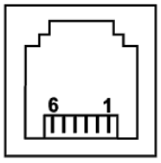

|  |  |  |  |
| --- | --- | --- | --- |
| **PIN** | **DESCRIPTION** | **PIN** | **DESCRIPTION** |
| 1 | MCLR/Vpp | 4 | PGD |
| 2 | VDD | 5 | PGC |
| 3 | GND | 6 | AUX |

**5****. HARDWARE**

This section will show the setup to use [UIC-A](http://cytron.com.my/p-uic-a) with [UIC00B](http://cytron.com.my/p-uic00b), [PICkit Programmer](http://cytron.com.my/p-pickit-3) or [Microchip In Circuit Debugger (ICD)](http://cytron.com.my/p-icd3).

Figure below shows that the Cytron UIC00B Standard can be converted to other type of standard by using UIC-A. Users may use PICkit Standard or IDC Standard to program their ICSP development board. Example below shows Cytron UIC00 Standard was converted to PICkit Out to load program into Microchip development board.

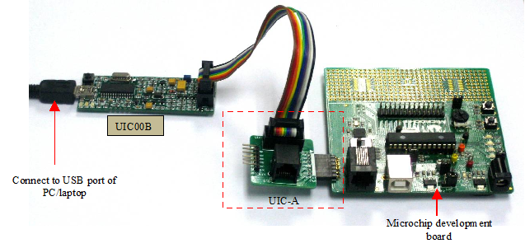

Figure below shows that the PICkit ICSP Standard can be converted to other type of standard by using UIC-A. Users may use Cytron UIC00B Standard or IDC Standard to program their ICSP development board. Example below shows PICkit ICSP Standard was converted to Cytron UIC00B Standard to load program into Cytron’s development board.

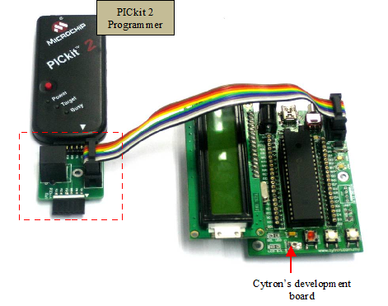

Figure below shows that the ICD ICSP Standard can be converted to other type of standard by using UIC-A. Users may use Cytron UIC00B Standard or PICkit Standard to program their ICSP development board. Example below shows ICD Standard was converted to Cytron UIC00B Standard to load program into Cytron’s development board.

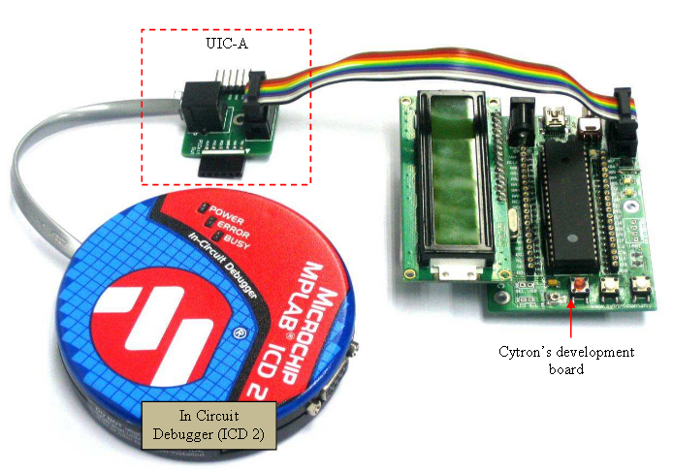

**6****. WARRANTY**

* Product warranty is valid for 12 months.
* Warranty only applies to manufacturing defect.
* Damaged caused by misuse is not covered under warranty
* Warranty does not cover freight cost for both ways.

*Prepared by*

***Cytron Technologies Sdn. Bhd.***

No. 16, Jalan Industri Ringan Permatang Tinggi 2,

Kawasan Industri Ringan Permatang Tinggi,   
14100 Simpang Ampat,  
Penang, Malaysia.

*Tel: +604 - 504 1878*

*Fax: +604 - 504 0138*

*URL:* [www.cytron.com.my](http://www.cytron.com.my/)

*Email:* [support@cytron.com.my](mailto:support@cytron.com.my)

[sales@cytron.com.my](mailto:sales@cytron.com.my)