**8x8 RGB 64 LED Dot Matrix Displays**

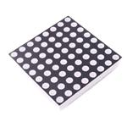

**Structural diagram**

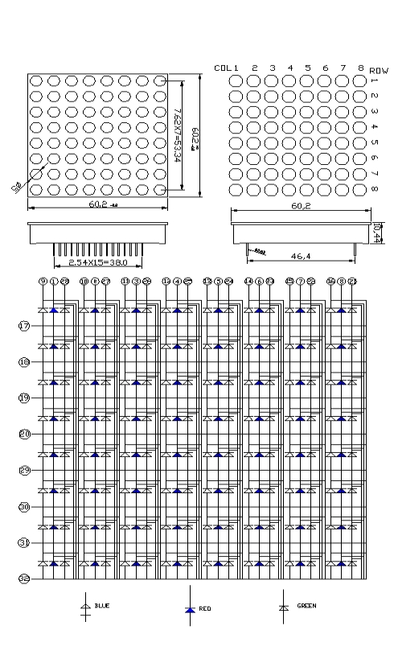

**Specification parameters**

|  |  |  |  |  |  |  |  |  |  |
| --- | --- | --- | --- | --- | --- | --- | --- | --- | --- |
| **Utilization parameters** | | | | | | | | | |
| Parameter | | Color | | | Maximum value | | | Unit | |
| Maximum Power | | Red | | | 70 | | | mW | |
| Green | | | 100 | | |
| Blue | | | 100 | | |
| Maximum forward current | | Red | | | 30 | | | mA | |
| Green | | | 30 | | |
| Blue | | | 30 | | |
| Reverse Voltage | | Red | | | 5 | | | V | |
| Green | | | 5 | | |
| Blue | | | 5 | | |
| Working Temperature | | | | | -30℃ to +80℃ | | | | |
| Storage Temperature | | | | | -30℃ to +100℃ | | | | |
| **Optical parameters** | | | | | | | | | |
| Parameter | Color | | Symbol | Minimum value | | Maximum value | Unit | | Test conditions |
| luminous intensity | Red | | Iv | 80 | | 100 | mcd | | IF=20mA |
| Green | | 180 | | 200 |
| Blue | | 50 | | 70 |
| Wavelength | Red | | λp | 625 | | 630 | nm | | IF=20mA |
| Green | | 517.5 | | 520 |
| Blue | | 467.5 | | 470 |
| Forward Voltage | Red | | VF | 1.9 | | 2.2 | V | | IF=20mA |
| Green | | 3.1 | | 3.4 |
| Blue | | 3.1 | | 3.4 |
| Reverse Current | Red | | IR | / | | 10 | UA | | VR=5V |
| Green | | / | | 10 |
| Blue | | / | | 10 |