**9225 DC5V Oil Containing Cooling Fan**

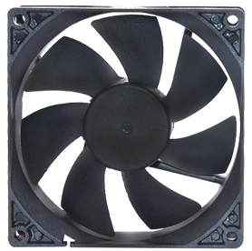

**Specification**

Voltage: DC 5V

Rated current: 0.2A

Size: 91.5*91.5*25MM

Power consumption: 1W

Speed: 2500±5%RPM

Noise: 24DBA

Weight: 67.5g

Bearing structure: oiled/double ball bearings

Wiring: red line positive, black line negative

Temperature range: -10+60°C

Storage humidity: 5 TO 95% RH

**Dimensional drawings**

