**DC12V 0.25A 8025 Oil Containing Cooling Fan with XH2.54-2P 30CM Cable**

**Size:80*80*25MM**

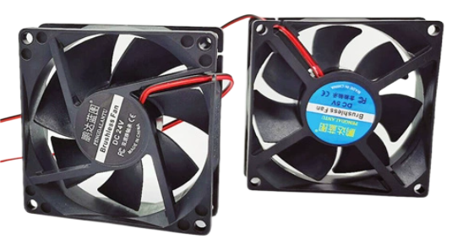

**Specification**

Rated voltage: DC12V

Rated current: 0.25A

Power consumption: 3.0W

Speed: 3600±10%RPM

Bearing: Oil bearing - double ball bearing

Airflow: 45CFM

Air Pressure: 0.24 Inches

Noise level: 36DBA

Life Expectancy: Constant temperature 40℃ Humidity 5%~95% 25000hrs 50000hrs

Net Weight: 59.1 grams

Dimension: 80*80*25MM

Operating Temperature/Humidity Range: Oil Contained -10~60℃ Humidity 5%~95%RH

Roller Ball -10~80℃

Installation Diameter: Hole Diameter: 4MM Fan Middle Circle Size: 34MM

Wiring instructions: red line positive, black line negative

Maximum diagonal diameter: 111MM

Diagonal Hole Distance: 101MM

**Dimensional drawings**

