**Dual Led 0.28 " Display for DC0-100V 100A Voltage and Current Test Digital Instrument, Digital Meter Panel Amplifier**

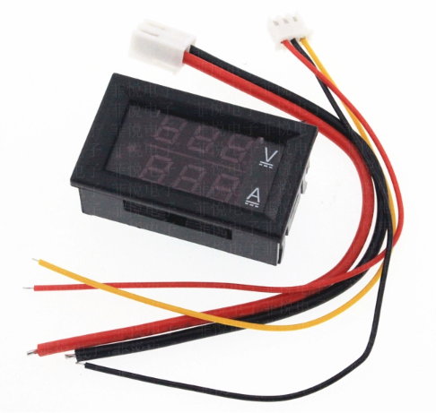

**Product Parameters**

Voltage measurement range: 0.0V-100V

Current test range: 0-100A

Power supply range: DC 4-30.0V

Voltage Error: ±0.1%

Current error: ± 1%

External shunt specification: 75 mOhm

Operating current: <20mA

Refresh speed: about 300mS once

Display mode: double triple 0.28 LED digital tube

Display color: red + red

Lead wire length: 15cm

Overall dimensions: 48x29x22mm, length X width X thickness;

Mounting hole: 46x27mm

Net weight: 22g

Gross weight: 23g

Operating Temperature: -10℃~+65℃

**Related instructions**

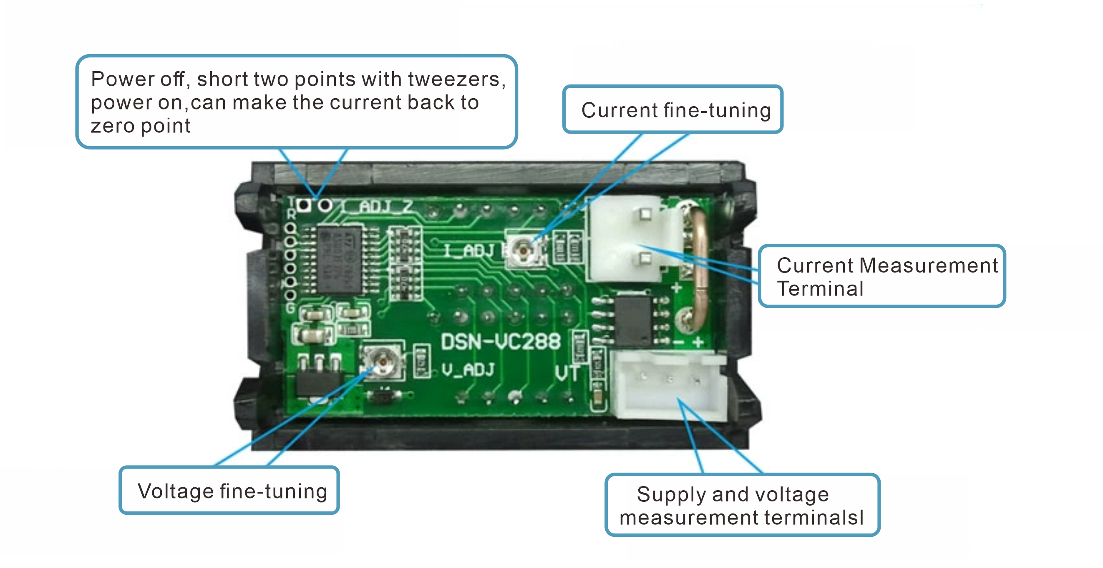

**Wiring Method**

**Direct power supply wiring diagram**

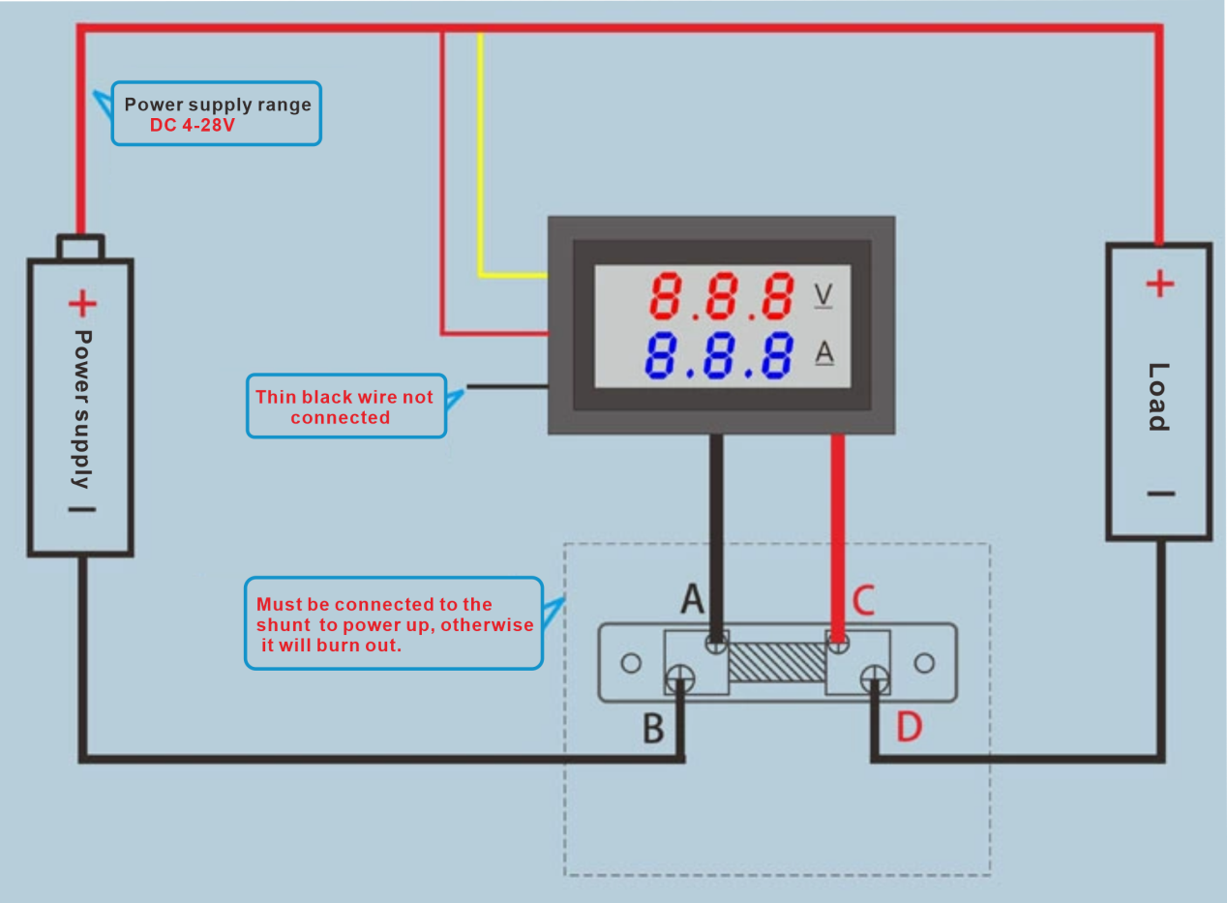

**Independent power supply wiring diagram**

