##### DC12V 433MHz learning code 3-button remote control

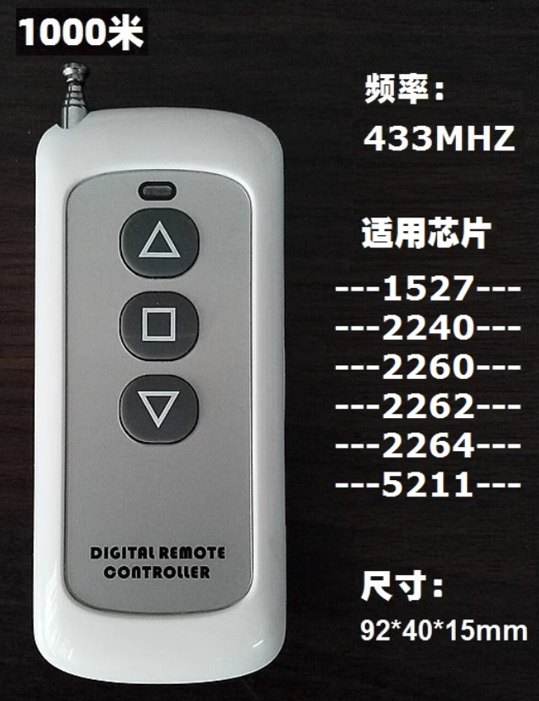

Check parameters

This copy remote control: can copy most common fixed code/learning code wireless radio frequency remote controls on the market, such as rolling shutter doors/rolling gates/retractable doors/barrier gates/access control/etc. Remote controls are not omnipotent. , so you need to check the remote control parameters. If the parameters are consistent, you can copy. -: First make sure that your original remote control is good and can be used normally. If it is bad, you cannot copy. 2: Disassemble your own remote control and check the frequency and chip

The numbers on components with metal shells represent frequencies, such as R315/R433, etc.

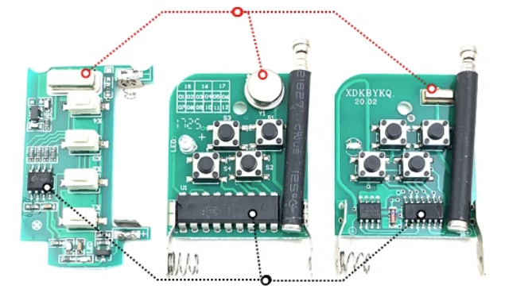

The numbers on the black square multi-pin components represent the chip model, such as 1527/2240/2260/2262/2264/5211, etc.

###### Instructions:

1. **clear code**

Note: Clearing the code means clearing the copy of the remote control you bought freshly, not clearing your own original remote control.

Press and hold the up key (A key) and down key (C key) at the same time. When you see the indicator light flashing, the clearing is successful. If it doesn't flash, try a few more times.

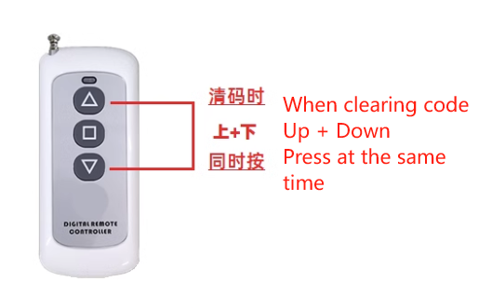

1. **Copy**

Note: Your original remote control must be good and usable, and it must be able to transmit signals normally.

Place the copy remote control and the original remote control side by side, with the copy remote control on the left and the original remote control on the right. Press and hold the corresponding buttons of the two remote controls for more than 1 second at the same time. When you see the indicator light of the copy remote control start to flash, then Copy successful. Use the same method to copy all other required keys.

