##### Electronic switch control board pulse trigger switch module DC control MOS field effect transistor

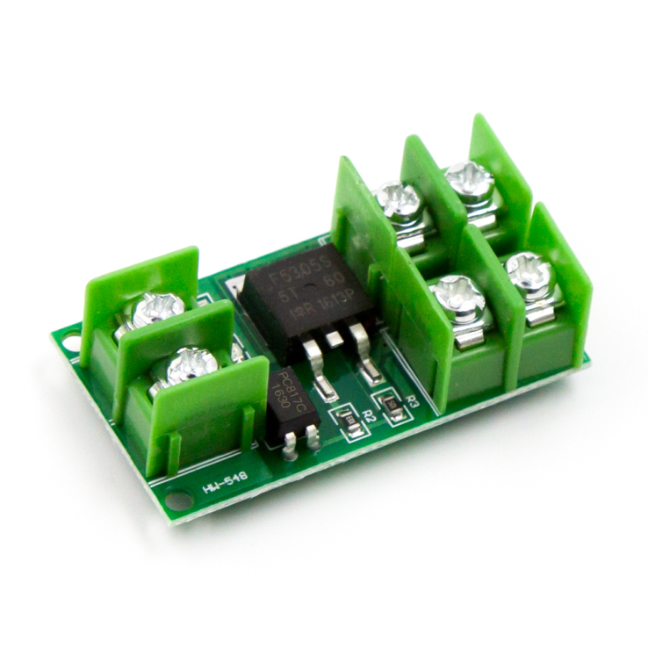

Product Introduction:

1: FET module, input and output are completely isolated.

2: Signal trigger terminal: digital quantity high and low level. Can be connected to MCU IO port, PLC interface, DC power supply, etc.

3: Input signal voltage: 3V~24V; Current: about 5ma.

4: The output end can control high-power equipment, motor, bulb, LED strip, DC motor, micro water pump, solenoid valve, etc

5: Output controlled voltage: 5V~36V. Current: within 5A greater than 5A need to add heat sink, the maximum can not exceed 20A.

6: Using the original F5305S power field effect transistor, can input PWM, control the motor speed, the brightness of the lamp, etc.

Product test video demo address: (5A motor used for testing, basically not heating)

http://v.youku.com/v_show/id_XOTQzMzA2MDQ0.html

6, OUT- : output terminal negative (connected to the device negative)