Grove - Gas Sensor V2(Multichannel)

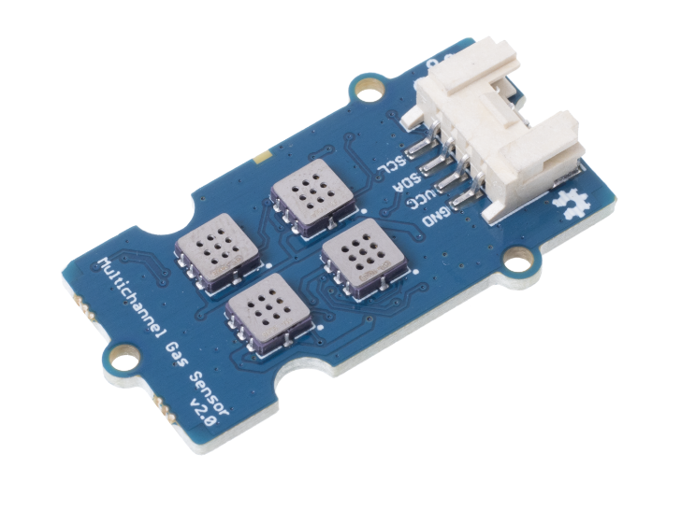

**Tip**

We've released the [Seeed Gas Sensor Selection Guide](https://wiki.seeedstudio.com/Sensor_gas/), it will help you choose the gas sensor that best suits your needs.

Grove - Multichannel Gas Sensor V2 has 4 measuring units, each of them is sensitive to various kinds of gases, which means you are able to get four sets of data at the same time. And different sorts of gases can also be judged by these four sets of data. The gas sensor used in this module is based on MEMS technology and has the advantage of being in a small size with considerable measurement stability and is more suitable for qualitative than quantitative measurement.

Features[¶](https://wiki.seeedstudio.com/Grove-Multichannel-Gas-Sensor-V2/#features)

* Four fully independent sensor elements on one package.
* The ability to detect a variety of gases, besides Carbon monoxide (CO), Nitrogen dioxide (NO2), Ethyl alcohol(C2H5CH), Volatile Organic Compounds (VOC) and etc.
* Qualitative detecting, rather than quantitative.
* Compact size for easy deployment.

Specification[¶](https://wiki.seeedstudio.com/Grove-Multichannel-Gas-Sensor-V2/#specification)

| Item | Value |
| --- | --- |
| MCU | STM32F030 |
| Interface | Grove I2C |
| I2C address | 0x55 |
| Output voltage | 3.3V~5V |
| Sensors | GM-102B; GM-302B; GM-502B; GM-702B |

**GM-102B**

| **Type of product** | GM-102B |
| --- | --- |
| **V0(V)** | 2.5-4.5 |
| **V0-VS(V)** | ≥1.0 |
| **Load** | Adjustable |
| **Response time（tres，S）** | ≤30 |
| **Recovery Time（trec，S）** | ≤60 |
| **Heating resistance（RH，Ω）** | 80±20 |
| **Operating Voltage（V）** | VH=2.0±0.1 AC or DC VC=5.0±0.1DC |

**GM-302B**

| **Type of product** | | | GM-302B |
| --- | --- | --- | --- |
| **Standard package** | | | Ceramic package |
| **Concentration** | | | 1～500ppm |
| **Standard circuit conditions** | Loop voltage | VC | ≤24V DC |
| Heating Voltage | VH | 2.5V±0.1V AC or DC |
| Load Resistance | RL | Adjustable |
| **Gas sensor characteristics under standard test conditions** | Heating resistance | RH | 60~100Ω（Room Temperature） |
| Heating power consumption | PH | ≤50mW |
| Sensitive body resistance | RS | 1KΩ～30KΩ(in 50ppm Ethanol ) |
| Sensitivity | S | Rs(in air)/Rs(in 50ppm Ethanol )≥3.0 |
| Concentration slope | α | ≤0.9(R200ppm/R50ppm Ethanol ) |
| **Standard test conditions** | Temperature/Humidity | | 20℃±2℃；55%±5%RH |
| Standard test circuit | | VH:2.5V±0.1V； VC:5.0V±0.1V |
| Preheat time | | Less than 48hrs |

**GM-502B**

**GM-702B**

| **Type of product** | | | GM-702B |
| --- | --- | --- | --- |
| **Standard package** | | | Ceramic package |
| **Concentration** | | | 5～5000ppm(CO) |
| **Standard circuit conditions** | Loop voltage | VC | ≤24V DC |
| Heating Voltage | VH | 2.5V±0.1V AC or DC（High Temperature） 0.5V±0.1V AC or DC（Low Temperature） |
| Load Resistance | RL | 60s±1s（H. T)；90s±1s（L. T） |
| **Gas sensor characteristics under standard test conditions** | Heating resistance | RH | Adjustable |
| Heating power consumption | PH | 80Ω±20Ω（Room temperature） |
| Sensitive body resistance | RS | ≤50mW |
| Sensitivity | S | 1KΩ～30KΩ(in 150ppmCO) |
| Concentration slope | α | R0(in air)/Rs(in 150ppmCO)≥3 |
| **Standard test conditions** | Temperature / Humidity | | 20℃±2℃；55%±5%RH |
| Standard test circuit | | VH: 2.5V±0.1V（H. T） 0.5V±0.1V（L. T） VC : 5.0V±0.1V |

| **Time：2019.06.27** | | | | | | | | |
| --- | --- | --- | --- | --- | --- | --- | --- | --- |
| **Test conditions：VH=2.5V，VC=3.3V** | | | | | | | | |
| **Type：GM-102B、GM-302B、GM-502B、GM-702B** | | | | | | | | |
| 1# | **Gas：NO2** | | | | **Gas：C2H5OH** | | | |
| Type | Initial value(V) | 5ppm(V) | Difference(V) | Type | Initial value(V) | 50ppm(V) | Difference(V) |
| GM-102B | 1.41 | 0.38 | -1.03 | GM-102B | 1.42 | 2 | 0.58 |
| GM-302B | 0.94 | 0.48 | -0.46 | GM-302B | 0.95 | 2.06 | 1.11 |
| GM-502B | 1.42 | 0.53 | -0.89 | GM-502B | 1.41 | 2.93 | 1.52 |
| GM-702B | 1.54 | 0.55 | -0.99 | GM-702B | 1.35 | 2.86 | 1.51 |
| 2# | **Gas：NO2** | | | | **Gas：C2H5OH** | | | |
| Type | Initial value(V) | 5ppm(V) | Difference(V) | Type | Initial value(V) | 50ppm(V) | Difference(V) |
| GM-102B | 0.94 | 0.22 | -0.72 | GM-102B | 0.92 | 1.41 | 0.49 |
| GM-302B | 0.45 | 0.24 | -0.21 | GM-302B | 0.35 | 2.09 | 1.74 |
| GM-502B | 1.45 | 0.49 | -0.96 | GM-502B | 1.51 | 2.88 | 1.37 |
| GM-702B | 0.77 | 0.3 | -0.47 | GM-702B | 0.74 | 2.73 | 1.99 |
| 3# | **Gas：NO2** | | | | **Gas：C2H5OH** | | | |
| Type | Initial value(V) | 5ppm(V) | Difference(V) | Type | Initial value(V) | 50ppm(V) | Difference(V) |
| GM-102B | 1.29 | 0.27 | -1.02 | GM-102B | 1.2 | 1.62 | 0.42 |
| GM-302B | 1.12 | 0.61 | -0.51 | GM-302B | 1.12 | 2.33 | 1.21 |
| GM-502B | 1.82 | 0.58 | -1.24 | GM-502B | 1.72 | 2.86 | 1.14 |
| GM-702B | 1.06 | 0.37 | -0.69 | GM-702B | 1.08 | 2.8 | 1.72 |
|  | | | | | | | | |
| 1# | **Gas：CO** | | | |  | | | |
| Type | Initial value(V) | 150ppm(V) | Difference(V) | Types of sensors | | Gases measured | |
| GM-102B | 1.31 | 1.33 | 0.02 | GM-102B | | NO2 | |
| GM-302B | 0.72 | 0.88 | 0.16 | GM-302B | | C2H5OH | |
| GM-502B | 1.33 | 1.35 | 0.02 | GM-502B | | VOC | |
| GM-702B | 1.22 | 2.09 | 0.87 | GM-702B | | CO | |
| 2# | **Gas：CO** | | | | **NOTICE: When it comes to judging what the gas is, GM-102B can be taken as an example. As it can be seen from the four charts above and beside, GM-102B has participated three times for each gas detecting. And its number of differences peaked at the most under the atmosphere of NO2 than other gases. Therefore GM-102B is sensible to NO2 and accordingly is able to detect NO2, which is applicable to other sensors and sorts of gases as well. When being put under other kinds of gases, the sensor is able to detect the gas which makes it the most differences.** | | | |
| Type | Initial value(V) | 150ppm(V) | Difference(V) |
| GM-102B | 0.94 | 0.95 | 0.01 |
| GM-302B | 0.36 | 0.48 | 0.12 |
| GM-502B | 1.46 | 1.5 | 0.04 |
| GM-702B | 0.72 | 1.18 | 0.46 |
| 3# | **Gas：CO** | | | |
| Type | Initial value(V) | 150ppm(V) | Difference(V) |
| GM-102B | 1.18 | 1.17 | -0.01 |
| GM-302B | 1.18 | 1.25 | 0.07 |
| GM-502B | 1.72 | 1.71 | -0.01 |
| GM-702B | 1.01 | 1.7 | 0.69 |
|  | Image | | | | Image | | | |
|  |
|  |
|  |
|  |
|  |
|  |
|  |
|  |
|  |
|  |
|  |
|  |
|  |
|  |
|  | Image | | | | Image | | | |  |
|  |
|  |
|  |
|  |
|  |
|  |
|  |
|  |
|  |
|  |
|  |
|  |
|  |
|  |

Sample test outcomes[¶](https://wiki.seeedstudio.com/Grove-Multichannel-Gas-Sensor-V2/#sample-test-outcomes)

Characteristic descriptions[¶](https://wiki.seeedstudio.com/Grove-Multichannel-Gas-Sensor-V2/#characteristic-descriptions)

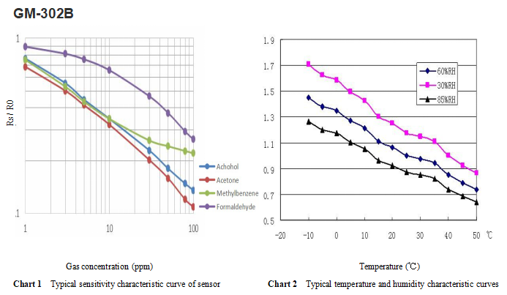

Rs in the figure represents the resistance value of the sensorin different concentrations of gas; R0 represents the resistance value of the sensor in clean air. All tests in the picture are completed under standard test conditions. Yellow line is Toluene, blue line is Ethanol, red line is Acetone and purple line is Formaldehyde, which is the same as the ones in charts below.

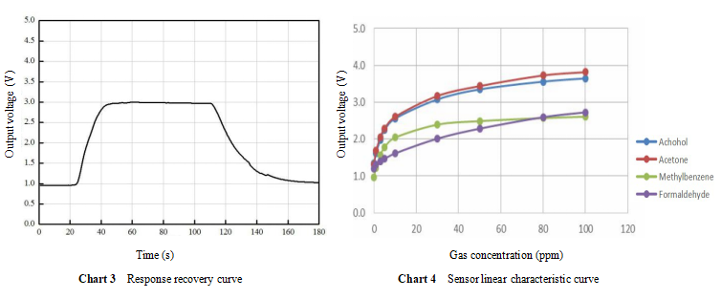

The output voltage in Chart 3 is the voltage across the load resistance (RL) of the sensor in series. The test in the figure is completed under standard test conditions, with a test gas of 50 ppm ethanol. The output voltage in Chart 4 is the voltage across the load resistance (RL) of the sensor in series. All tests in the figure are completed under standard test conditions.

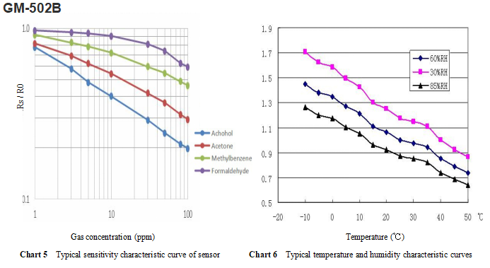

Rs in Chart 5 represents the resistance value of the sensorin different concentrations of gas; R0 represents the resistance value of the sensor in clean air. All tests in the picture are completed under standard test conditions. Yellow line is Toluene, blue line is Ethanol, red line is Acetone and purple line is Formaldehyde, which is the same as the ones in charts below. In Chart 6, Rs represents the resistance value under 50ppm ethanol and various temperatures / humidities; Rs0 represents the resistance value under 50ppm ethanol, 20 ℃ and 55% RH.

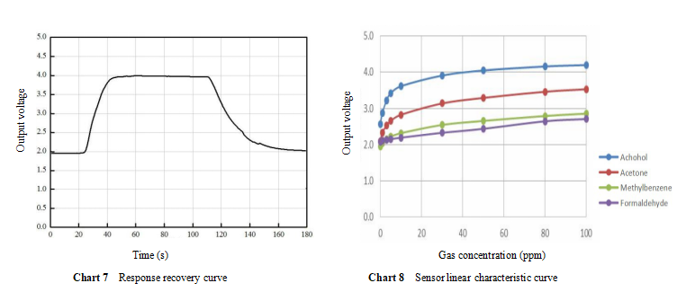

The output voltage in Chart 7 is the voltage across the load resistance (RL) of the sensor in series. The test in the figure is completed under standard test conditions, with a test gas of 50 ppm ethanol. The output voltage in Chart 8 is the voltage across the load resistance (RL) of the sensor in series. All tests in the figure are completed under standard test conditions.

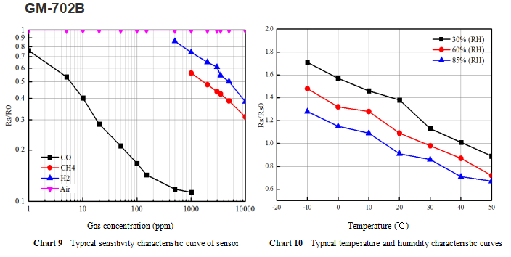

In Chart 9, Rs represents the resistance of the sensor in different concentrations of gas Value; R0 represents the resistance value of the sensor in clean air. All tests in the picture are completed under standard test conditions. The black line is for CO, red one is CH4, Purple is for H2 and pink one is Air.In Chart 10 , Rs represents the temperature at 150ppmCO and various temperatures / humidities. Resistance value; Rs0 means resistance value under 150ppmCO, 20 ℃, 55% RH.

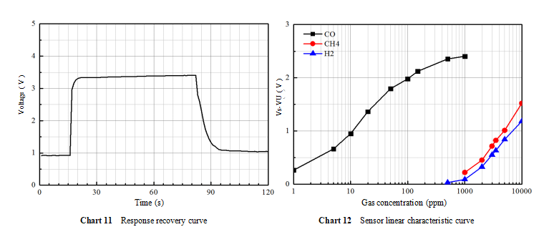

The voltage in Chart 11 is the voltage across the load resistance (RL) of the sensor in series. The test in the picture is completed under standard test conditions, test gas 150ppmCO. The output voltage in Chart 12 is the voltage across the load resistance (RL) of the sensor in series. All tests in the picture are completed under standard test conditions.

Platform Supported[¶](https://wiki.seeedstudio.com/Grove-Multichannel-Gas-Sensor-V2/#platform-supported)

| Arduino | Raspberry Pi |  |  |  |
| --- | --- | --- | --- | --- |
|  |  |  |  |  |

Getting Started[¶](https://wiki.seeedstudio.com/Grove-Multichannel-Gas-Sensor-V2/#getting-started)

**Materials Requied[¶](https://wiki.seeedstudio.com/Grove-Multichannel-Gas-Sensor-V2/" \l "materials-requied" \o "Permanent link)**

| Wio Terminal | Grove-Multichannel Gas Sensor V2 |
| --- | --- |
| enter image description here | enter image description here |
| [Get ONE Now](https://www.seeedstudio.com/Wio-Terminal-p-4509.html) | [Get ONE Now](https://www.seeedstudio.com/Grove-Multichannel-Gas-Sensor-v2-p-4569.html) |

**Hardware Overview**[**¶**](https://wiki.seeedstudio.com/Grove-Multichannel-Gas-Sensor-V2/#hardware-overview)

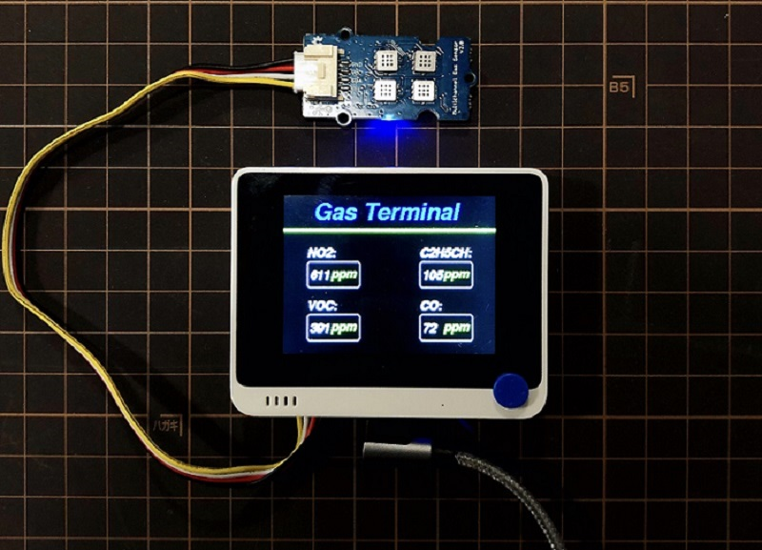 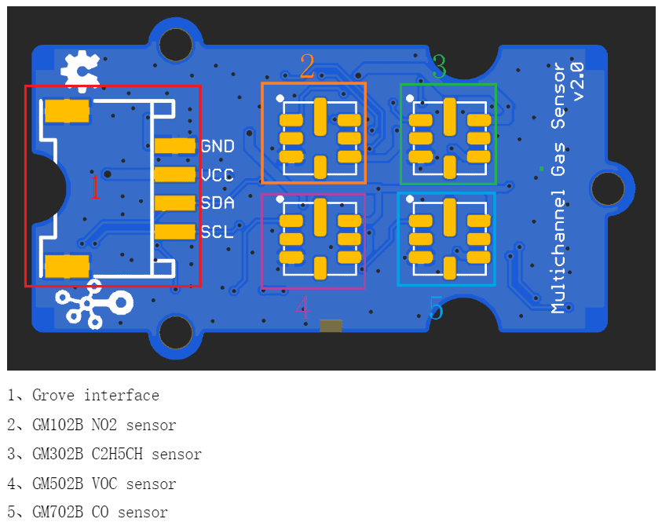

**Notice**

The module in the image of Hardware Connection has the same arrangement as the one in the image of Hardware Diagram above. As you can see in the Hardware Diagram, the outlined area in the left is the Grove Interface. And there are four squares with tiny holes refer to the gas sensors. When the board with sensors is connected with Wio Terminal, the information of the gases will display on the screen.

* **Step 1.** Connect Grove - Multichannel Gas Sensor V2 to port I2C of Grove-Base Shield. Plug Grove - Base Shield into Wio Terminal. And connect Wio Terminal to PC via a USB cable.
* **Step 2.** Download the [Grove_Multichannel_Gas_Sensor_v2 Library](https://github.com/Seeed-Studio/Seeed_Multichannel_Gas_Sensor/archive/master.zip) from Github. And refer [How to install library](https://wiki.seeedstudio.com/How_to_install_Arduino_Library) to install library for Arduino.
* **Step 3.** Copy the code into Wio Terminal and upload. If you do not know how to upload the code, please check [how to upload code](https://wiki.seeedstudio.com/Wio-Terminal-Getting-Started/).
* **Step 4.** Refer [How to TFT LCD Library](https://wiki.seeedstudio.com/Wio-Terminal-LCD-Overview/) to install TFT LCD Library. Lastly, upload code from the Software Code below and the data has to be displayed successfully.

**Software Code**[**¶**](https://wiki.seeedstudio.com/Grove-Multichannel-Gas-Sensor-V2/#software-code)

|  |  |
| --- | --- |
|  | *#include <TFT_eSPI.h>* |
|  | *#include <Multichannel_Gas_GMXXX.h>* |
|  | *#include <Wire.h>* |
|  | GAS_GMXXX<TwoWire> gas; |
|  |  |
|  | TFT_eSPI tft; |
|  | // Stock font and GFXFF reference handle |
|  | TFT_eSprite spr = TFT_eSprite(&tft); // Sprite |
|  |  |
|  | void setup() { |
|  | // put your setup code here, to run once: |
|  | tft.begin(); |
|  | tft.setRotation(3); |
|  | spr.createSprite(tft.width(),tft.height()); |
|  | gas.begin(Wire, 0x08); // use the hardware I2C |
|  | } |
|  |  |
|  | void loop() { |
|  | // put your main code here, to run repeatedly: |
|  | int val; |
|  | spr.fillSprite(TFT_BLACK); |
|  | spr.setFreeFont(&FreeSansBoldOblique18pt7b); |
|  | spr.setTextColor(TFT_BLUE); |
|  | spr.drawString("Gas Terminal", 60 - 15, 10 , 1);// Print the test text in the custom font |
|  | for(int8_t line_index = 0;line_index < 5 ; line_index++) |
|  | { |
|  | spr.drawLine(0, 50 + line_index, tft.width(), 50 + line_index, TFT_GREEN); |
|  | } |
|  |  |
|  | spr.setFreeFont(&FreeSansBoldOblique9pt7b); // Select the font |
|  | // GM102B NO2 sensor |
|  | val = gas.getGM102B(); |
|  | if (val > 999) val = 999; |
|  | spr.setTextColor(TFT_WHITE); |
|  | spr.drawString("NO2:", 60 - 24, 100 -24 , 1);// Print the test text in the custom font |
|  | spr.drawRoundRect(60 - 24,100,80,40,5,TFT_WHITE); |
|  | spr.setTextColor(TFT_WHITE); |
|  | spr.drawNumber(val,60 - 20,100+10,1); |
|  | spr.setTextColor(TFT_GREEN); |
|  | spr.drawString("ppm", 60 + 12, 100+8, 1); |
|  | // GM302B C2H5CH sensor |
|  | val = gas.getGM302B(); |
|  | if (val > 999) val = 999; |
|  | spr.setTextColor(TFT_WHITE); |
|  | spr.drawString("C2H5CH:", 230 -24 , 100 - 24 , 1);// Print the test text in the custom font |
|  | spr.drawRoundRect(230 - 24,100,80,40,5,TFT_WHITE); |
|  | spr.setTextColor(TFT_WHITE); |
|  | spr.drawNumber(val,230 - 20,100+10,1); |
|  | spr.setTextColor(TFT_GREEN); |
|  | spr.drawString("ppm", 230 + 12, 100+8, 1); |
|  | // GM502B VOC sensor |
|  | val = gas.getGM502B(); |
|  | if (val > 999) val = 999; |
|  | spr.setTextColor(TFT_WHITE); |
|  | spr.drawString("VOC:", 60 - 24, 180 -24 , 1);// Print the test text in the custom font |
|  | spr.drawRoundRect(60 - 24,180,80,40,5,TFT_WHITE); |
|  | spr.setTextColor(TFT_WHITE); |
|  | spr.drawNumber(val,60 - 20,180+10,1); |
|  | spr.setTextColor(TFT_GREEN); |
|  | spr.drawString("ppm", 60 + 12, 180+8, 1); |
|  | // GM702B CO sensor |
|  | val = gas.getGM702B(); |
|  | if (val > 999) val = 999; |
|  | spr.setTextColor(TFT_WHITE); |
|  | spr.drawString("CO:", 230 -24 , 180 - 24, 1);// Print the test text in the custom font |
|  | spr.drawRoundRect(230 - 24 ,180,80,40,5,TFT_WHITE); |
|  | spr.setTextColor(TFT_WHITE); |
|  | spr.drawNumber(val ,230 - 20 ,180+10,1); |
|  | spr.setTextColor(TFT_GREEN); |
|  | spr.drawString("ppm", 230 + 12, 180+8, 1); |
|  |  |
|  | spr.pushSprite(0, 0); |
|  | delay(100); |
|  |  |
|  | } |

**Cautions**

* The module should avoid being placed in the volatile silicon compound steam, or it will cause the sensitivity to be reduced and irrecoverable.
* The module should avoid being exposured to high concentrations of corrosive gases (such as H2S, SOX, Cl2, HCl, etc.), otherwise it will be irreversibly damaged.
* The module should not be placed in water or ice.
* After the module is powered on, the sensor will heat up to a certain degree during the process, which is a normal phenomena.
* Users MUST preheat the module before starting measuring gases.

Schematic Online Viewer[¶](https://wiki.seeedstudio.com/Grove-Multichannel-Gas-Sensor-V2/#schematic-online-viewer)

Resources[¶](https://wiki.seeedstudio.com/Grove-Multichannel-Gas-Sensor-V2/#resources)

* **[Zip]** [Grove_Multichannel_Gas_Sensor_v2 Library](https://github.com/Seeed-Studio/Seeed_Multichannel_Gas_Sensor/archive/master.zip)
* **[PDF]** [GM-102B Technical Parameter.pdf](https://files.seeedstudio.com/wiki/Grove-Multichannel_Gas_Sensor/img/Grove-Multichannel_Gas_Sensor_V2_101020820/res/GM-102B+Technical+Parameter.pdf)
* **[PDF]** [GM-302B MEMS Technical Parameterv2.1.pdf](https://files.seeedstudio.com/wiki/Grove-Multichannel_Gas_Sensor/img/Grove-Multichannel_Gas_Sensor_V2_101020820/res/GM-302B+MEMS+Technical+Parameterv2.1.pdf)
* **[PDF]** [GM-502B MEMS VOC Technical Parameter v2.1.pdf](https://files.seeedstudio.com/wiki/Grove-Multichannel_Gas_Sensor/img/Grove-Multichannel_Gas_Sensor_V2_101020820/res/GM-502B+MEMS+VOC+Technical+Parameter+v2.1.pdf)
* **[PDF]** [GM-702B Technical Parameter(Ver1.1).pdf](https://files.seeedstudio.com/wiki/Grove-Multichannel_Gas_Sensor/img/Grove-Multichannel_Gas_Sensor_V2_101020820/res/GM-702B+Technical+Parameter(Ver1.1).pdf)

| **Type of product** | | | GM-502B |
| --- | --- | --- | --- |
| **Standard package** | | | Ceramic package |
| **Concentration** | | | 1～500ppm |
| **Standard circuit conditions** | Loop voltage | VC | ≤24V DC |
| Heating Voltage | VH | 2.5V±0.1V AC or DC |
| Load Resistance | RL | Adjustable |
| **Gas sensor characteristics under standard test conditions** | Heating resistance | RH | 80Ω ± 20Ω（Room temperature） |
| Heating power consumption | PH | ≤50mW |
| Sensitive body resistance | RS | 1KΩ～30KΩ (in 50ppm Ethanol) |
| Sensitivity | S | R0 (in air) / Rs (in 50ppm Ethanol) ≥3.0 |
| Concentration slope | α | ≤0.9 (R200ppm / R50ppm Ethanol) |
| **Standard test conditions** | Temperature / Humidity | | 20℃ ± 2℃；55% ± 5%RH |
| Standard test circuit | | VH:2.5V ± 0.1V； VC:5.0V ± 0.1V |