Sonoff 4CH PRO R3 WiFi+RF 433MHz - 4-channel switch

Module with **4 relays** for controlling devices powered by **230 V AC**. The control is performed using **WiFi** or radio communication with a frequency of**433 MHz**. On the housing of the controller there are also buttons for manual control of each channel. Thanks to compatibility with Amazon Alexa and Google Assistant, the device can be controlled using **voice commands**. The controller allows you to control 230 V lighting, roller shutters, garage door, fan, among other things. The housing has the ability to mount on a DIN rail.

Top of Form

**Product description: Sonoff 4CH PRO R3 WiFi+RF 433MHz - 4 channel switch**

Module with**4 relays**to control devices powered by**230V AC**. Control is done using[**WiFi**](https://botland.store/377-wi-fi-modules)or radio frequency**433 MHz**wireless communication. There are also buttons on the controller housing for manual control of each channel. Thanks to compatibility with Amazon Alexa and Google Assistant, the device can be controlled using**voice commands**. The controller allows you to control 230 V lighting, roller shutters, garage door, fan, among other things. The housing has the possibility of mounting on a DIN rail.

[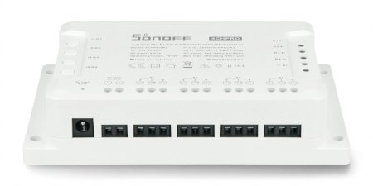](https://botland.store/img/art/inne/19142_2.jpg)

**Main features of Sonoff 4CH Pro module**

* Remote control of devices via application or 433 MHz RF remote control.
* 3 modes of operation: self-locking, interlock, inching.
* Allows you to create schedules for switching devices on and off.
* Allows you to create scenes to control a group of devices.
* Can be connected to other systems.
* Possibility of checking whether a device is on or off in real time through the application.

**Example of connection of Sonoff 4CH Pro controller**

Before you make the connection, make sure that you have disconnected power supply in the given circuit. The device can be mounted on a**DIN**rail or on the wall thanks to holes located on the casing.

The controller is equipped with**screw connectors**that allow you to connect the wires using a screwdriver. On the casing of Sonoff 4CH Pro there are buttons for manual control of each channel and status LEDs. The controller itself can be powered by**230 V AC or from 9 V to 23 V DC**.

[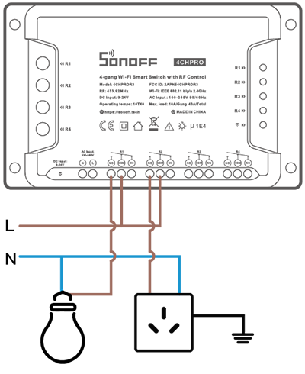](https://botland.store/img/art/inne/19142_6.jpg)*Example of connection of Sonoff 4CH Pro.*

[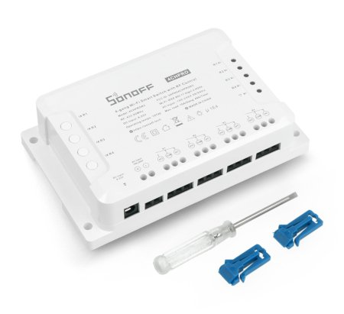](https://botland.store/img/art/inne/19142_3.jpg)*Elements included in the set with Sonoff 4CH Pro.*

**Sonoff 4CH Pro specification**

* Operating voltage: from 100 V to 240 V AC, 50/60 Hz and from 9 V to 23 V DC
* Maximum load: 10 A (2200 W) per channel / 40 A (8800 W) for the whole device
* Communication: WiFi 2.4 GHz / RF 433 MHz
* WiFi Standard: IEEE802.11 b/g/n
* Encryption mechanism: WPA / WPA2
* Housing material: PVC0
* Number of channels: 4
* Operating temperature: from -10°C to 40°C
* Humidity: from 5% to 95% RH
* Dimensions: 145 x 90 x 34 mm