**List of Modules and their Comparison**

**Standard M.2 B KEY Slot**

Compatible With SIM7600X-M.2, SIM7906X-M.2, A7906X-M.2 Series Modules.

**SIM7600G-H**

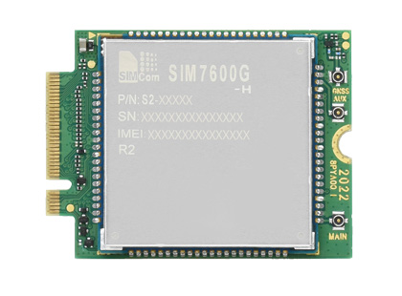

[**SIM7906X-M.2**](https://www.waveshare.com/sim7600x-h-m2.htm)

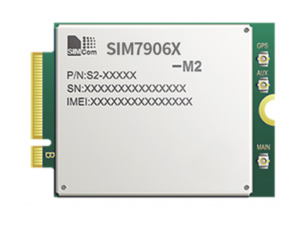

**SIMA7906X-M.2**

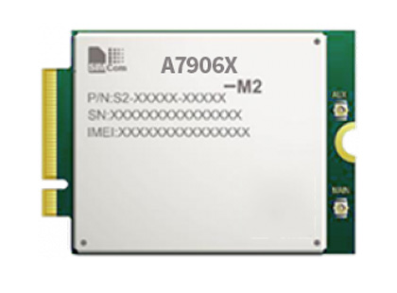

===========================================================================

**Comparing The SIM7600 Series**

|  |  |  |  |  |  |  |
| --- | --- | --- | --- | --- | --- | --- |
|  | | **SIM7600A-H** | **SIM7600SA-H** | **SIM7600E-H** | **SIM7600NA-H** | [SIM7600G-H](https://www.waveshare.com/sim7600x-h-m2.htm) |
| **FORM FACTOR** | | M.2 | | | | |
| **DIMENSIONS** | | 42.0 × 31.4 × 3.8 (mm) | | | | |
| **FREQ.** **BAND** | **LTE-FDD** | B2, B4, B12 | B1, B2, B3, B4, B5, B7, B8, B28, B66 | B1, B3, B5, B7, B8, B20 | B2, B4, B5, B12, B13, B14, B25, B26, B66, B71 | B1, B2, B3, B4, B5, B7, B8, B12, B13, B18, B19, B20, B25, B26, B28, B66 |
| **LTE-TDD** |  | B40 | B38, B40, B41 | B41 | B34, B38, B39, B40, B41 |
| **WCDMA** | B2, B5 | B1, B2, B5, B8 | B1, B5, B8 |  | B1, B2, B4, B5, B6, B8, B19 |
| **GSM** |  | 850, 900, 1800, 1900MHz | 900, 1800MHz |  | 850, 900, 1800, 1900MHz |
| **GNSS** | | GPS, Beidou, GLONASS, GALILEO, QZSS | | | | |
| **APPLICABLE REGIONS** | | North America (AT&T) | Australia, New Zealand, Taiwan, Latin America | Europe, the Middle East, Africa, South Korea, Thailand | North America (all providers) | Global |

===========================================================================